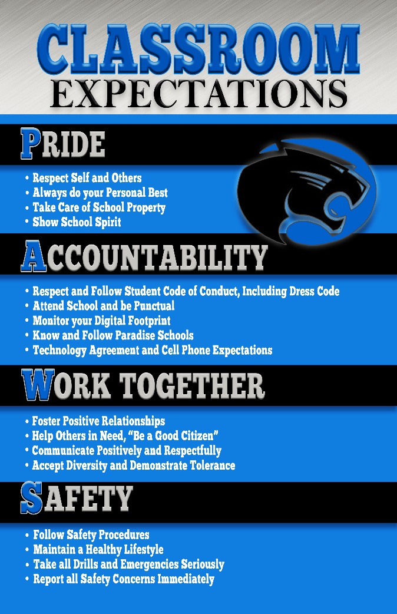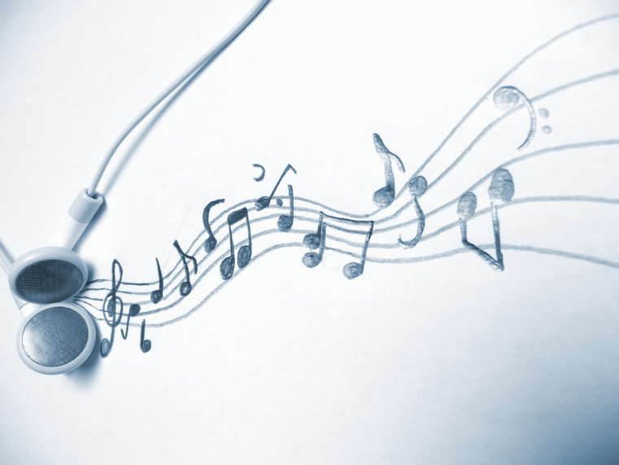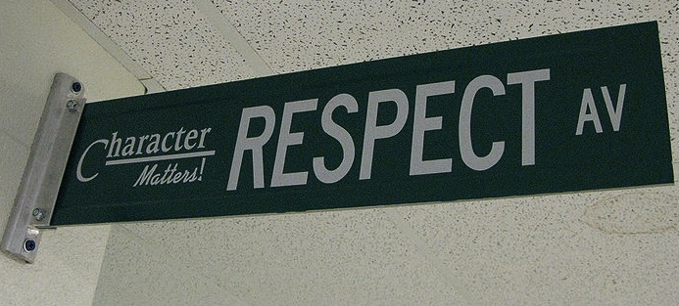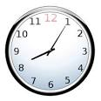

* Attentively listen to, recognize, describe and perform the characteristics of various works of music, such as melody, rhythm, harmony, texture, form, articulation, dynamics, and instrumentation.
* Identify and perform various musical features, historical and cultural background, important artists, and key theory elements associated with various genres of music.
* Connect various musical genres and musical works to real world application of technical and expressive qualities in musical performances in rehearsal and concert settings.
* See Choral Handbook for more detail on performances and expectations.

## Course Objectives

**Choir I:** This is an entry-level choir for both male and female students interested in vocal music performance.  It is also an outlet for the student who enjoys singing for his/her own pleasure.  The following musical skills for ensemble singing will be stressed:  proper breathing, pleasant vocal production, blend and balance, expansion of range, good intonation, ear training, and sight-reading. Various styles of choral literature will be explored. Participation in performances is an expectation of the class, which is part of the course grade.  These activities are integral elements that support and extend learning in the classroom.

**Concert Choir**: Students will sing new literature for each semester. Repertoire will be varied but thematic and provide a variety of styles, languages, and genres to the singers.

# Course Description

### Class Expectations

choir I II III/ concert choir

*Please refer to the PHHS Handbook for detailed information on classroom grading, technology, and school discipline policy.*

*“Music expresses that which cannot be put into words and cannot remain silent.”*

* *Victor Hugo*
* **Warning**
* **Phone Call Home**
* **Lunch Detention**
* **Office Referral**

## Classroom

## Consequences

**YOU WILL NEED:**

* Black three ring binder (1 in.)
* Loose leaf paper
* Pencils
* A set of highlighters
* Sticky notes
* Earbuds that work with chromebooks
* Join Remind

DUE BY: Wednesday, August 7th

**Entering Class:** Gather any necessary materials, quickly find your seat, and begin working on the assignment posted on the board. This is a timed five-minute activity.

**Office Hours:** I am available after school Mon and Tues. Please make an appointment if any additional time is needed.

**Food and Drinks:** Only water is permitted inside the classroom.

**Technology policy:** Please see PHHS Handbook for policy on the use of electronic devices in the classroom.

**Exiting Class:** In the last five minutes of class, you will wrap up what you are working on and return materials to the appropriate locations. The teacher, not the bell, dismisses you upon completion of these tasks.

**Absences:** If you are absent, it is your responsibility to make up missed assignments. You have one day to make up missed assignments for each day absent.

**Grading Policy:**

90-100% A (4.00)

80-89% B (3.00)

70-79% C (2.00)

<69% Failing: No credit

shall be earned

## Classroom Policies, Procedures, & Grading